🡪Update local cache

Python-devel: Libraries and source.. In future if we want to build any plugin

Pip: Plugin manager or Module manager for python...

**These dependencies are required for some of modules, because Ansibe run playbooks that are written in Python**

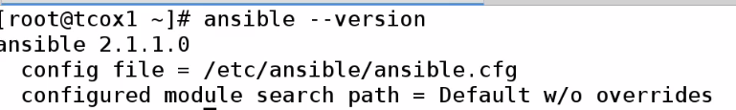

**Change Config:**



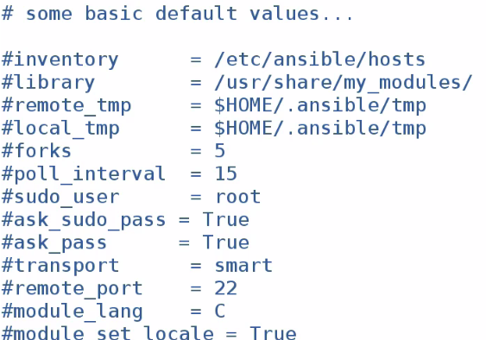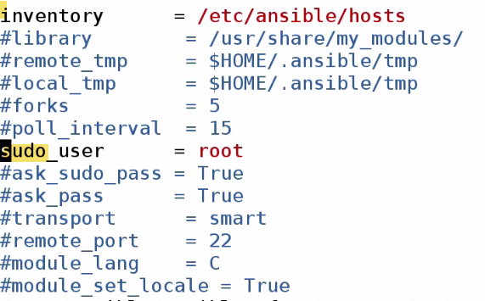

**Inventory: We can specify other inventory locations. In this case, we are going to have global Inventory hosts file.**

**When we run commands as sudo, then it will run as root user.**

**There are also ssh values, module, bash values in this file.**

**As there is no daemon running in Ansible, not required to restart. Ansible will read config file.., every time we run Ansible cmds.**

**When we run Ansible cmds or playbooks, we run against Nodes (identified by name). Names are like DNS entry, indicated by values in hosts file.**

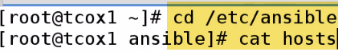****

**We created 3 groups**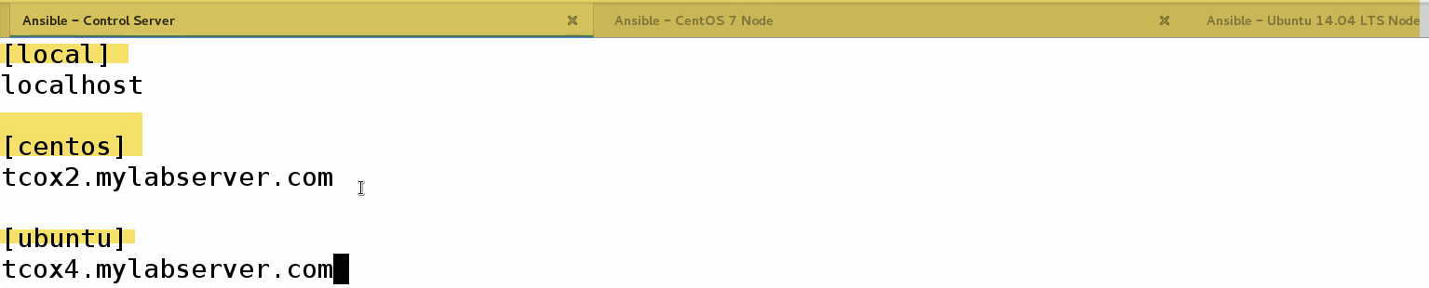

**We typically run Ansible commands as sudo user**

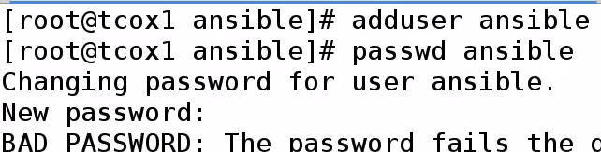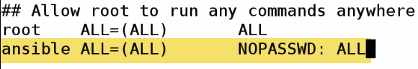**We need to create user accounts on each of nodes that we are going to manage with Ansible**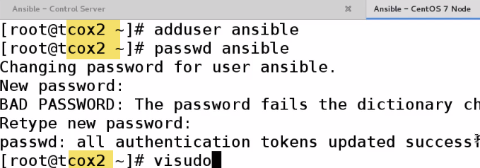

Since we operate over ssh, and we will not be passing password using sudo.

We can password..however we run playbooks as part of cron job, Jenkins job..So we don’t want to provide password.

**We have to setup ssh keygen:(WRONG BE ANSIBLE UER)** 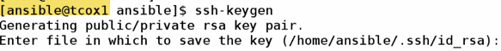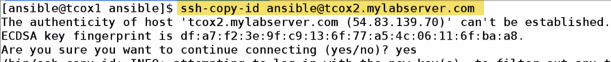

Now to Ubuntu: 

For localhosts: We need to copy-id to ourselves..Otherwise ssh to localhost fails without keyexchange..

**Even for connection to localhost will ask for password**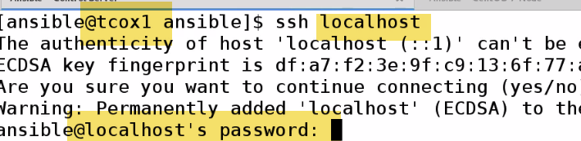



**Summary:** Installed Ansible and its dependencies

Made cople changes to Ansible.cfg

As there is no daemon running in Ansible, not required to restart. Ansible will read config file.., every time we run Ansible cmds.

Created hosts file, with 1 node in each group

Created Ansible user, and provided sudo user.

Exchanged keys nodes as well as local(Ansible server functions as local node) and nodes.

-🡪 Ansible Documentation:

**Docs.Ansible.com**🡪Owned by redhat..Certifications: 2---Ansible, Ansible Tower(Enterprise)—Reporting, graphing, with support

We already setup our inventory: /etc/hosts file which contains groups of individual nodes we may choose to run playbooks against... Inventory can contain Individual nodes, groups, patterns etc.

We can Ranges of Ips, ports, names..

Playbooks: Text file that contains YAML formatted options that tells Ansible what to do, what modules to run, what options to use in order to connect to Nodes to perform various work.

Playbooks run remotely through SSH on remote server..

Update Cache(repo) and install particular pkg: foo.

We can say install if absent, install update-to date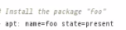

We will see simpler: install/update/remove users…

Let’s say I need to update simple config. On whole bunch of servers in my env.. I only want to run 1 command and update all. ..No need to complex like login to using ssh and udate all , setup..

As long as SSH setup, user and key exchange, can update/install pkgs across bunch of servers, And also. What distribution it is...

-🡪 Running Ansible Commands:

Cmd: Going to use Ansible module or not going to use module.

To do something on group of nodes or pull info. About node. This is similar to running playbook; however playbook is constructed in file..

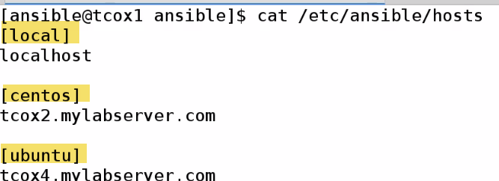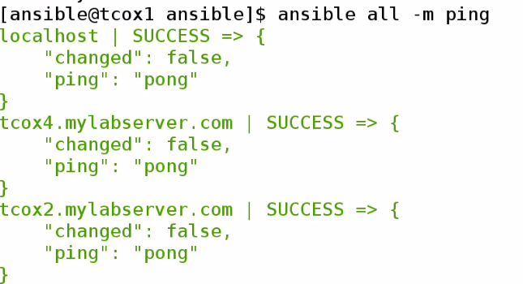all-> Run on all(default for all nodes on hostsfile)

-a🡪Run an arbitrary command (whatever is behind this parameter)

-m🡪Use following module (like ping). 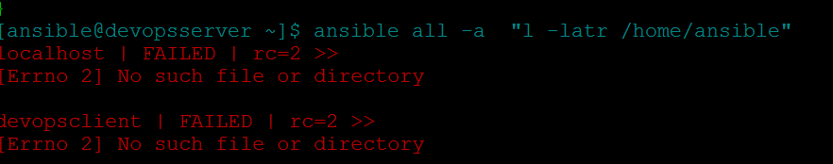

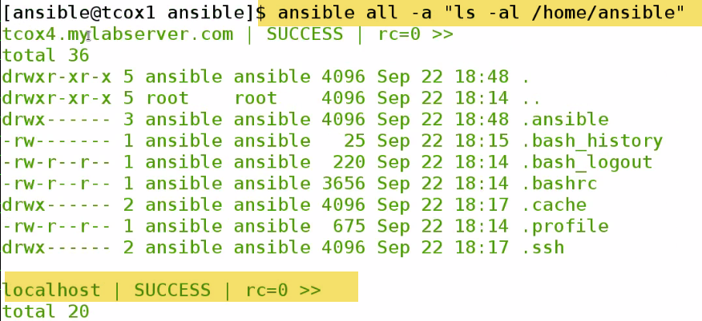

0-> success

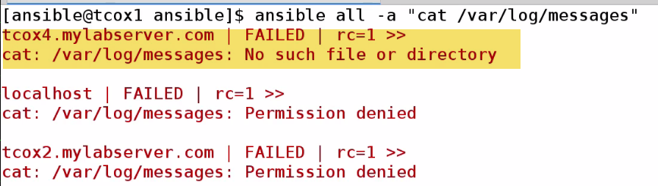

Root can only cat.. DO sudo

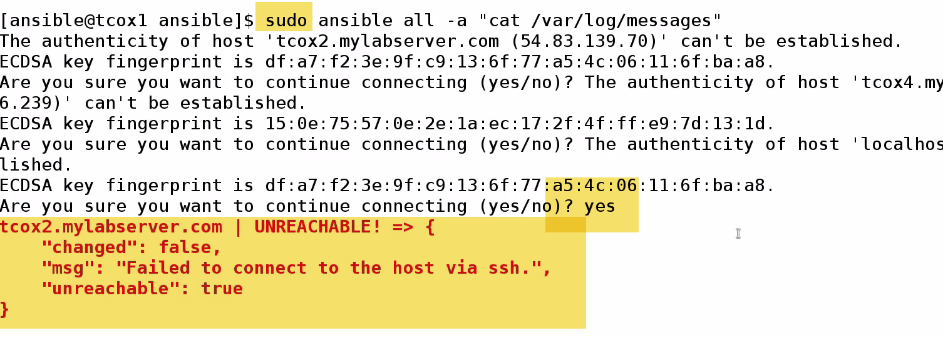

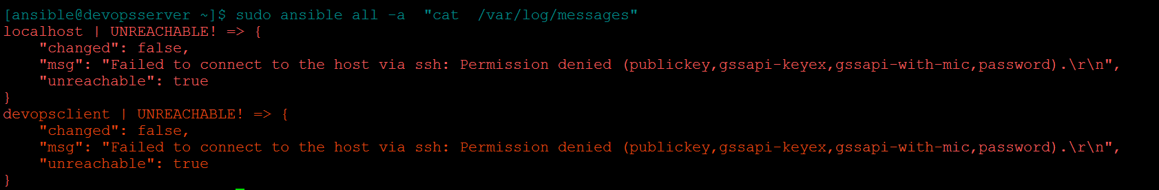

1.) It is asking for prompt

2.) Failing to connect using SSH??

Because, when I do sudo, it is trying to be as root user. I didn’t exchange root keys with individual nodes.

How to run privileged commands with Ansible user???

Why did we setup visudo (/etc/sudoers) –NOPASSWD???..Because there is facility in Ansible to use sudo root if we pass -s ..It will run command-elevating previlage of Ansible user to sudo(ASSUMING WE SET SUDO PRIVILEGES UP) on remote keys..And as we exchanged keys and indicated NOPASSWD…

-s

🡪Only on local

**COPY**

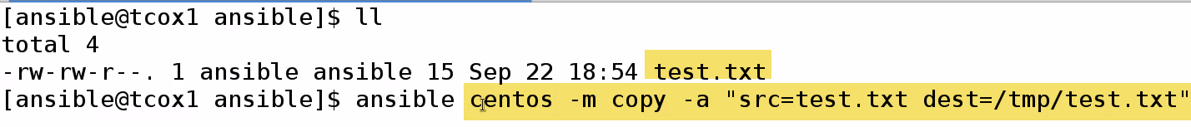

I have file test.txt

Execute command against Centos group(1 node) using module COPY with following attributes

Copying src file test.txt to dest file test.txt in /tmp dir.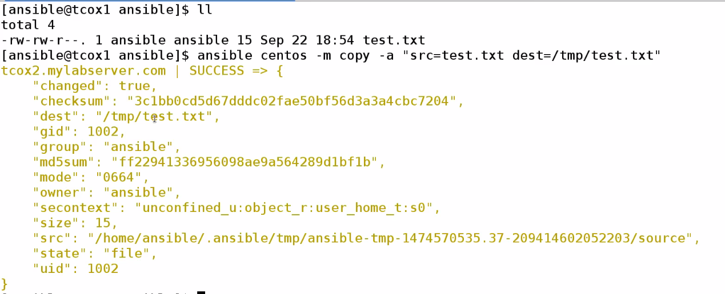

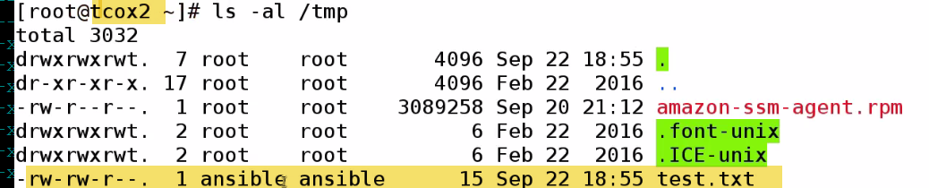

On Centos, see on /tmp test.txt created by Ansible user

🡪**Install pkgs**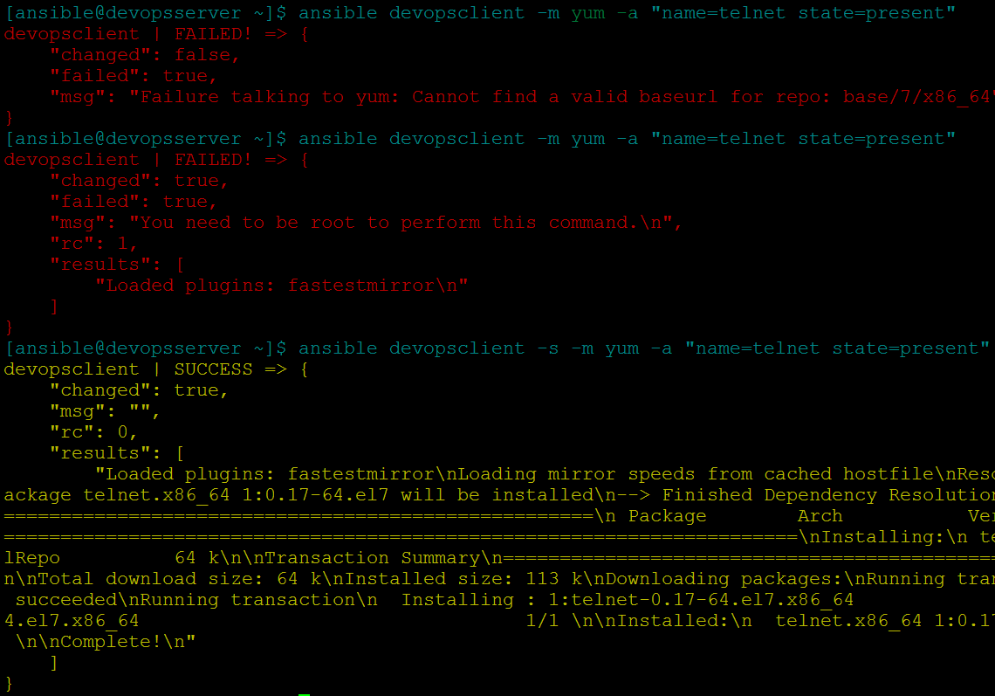

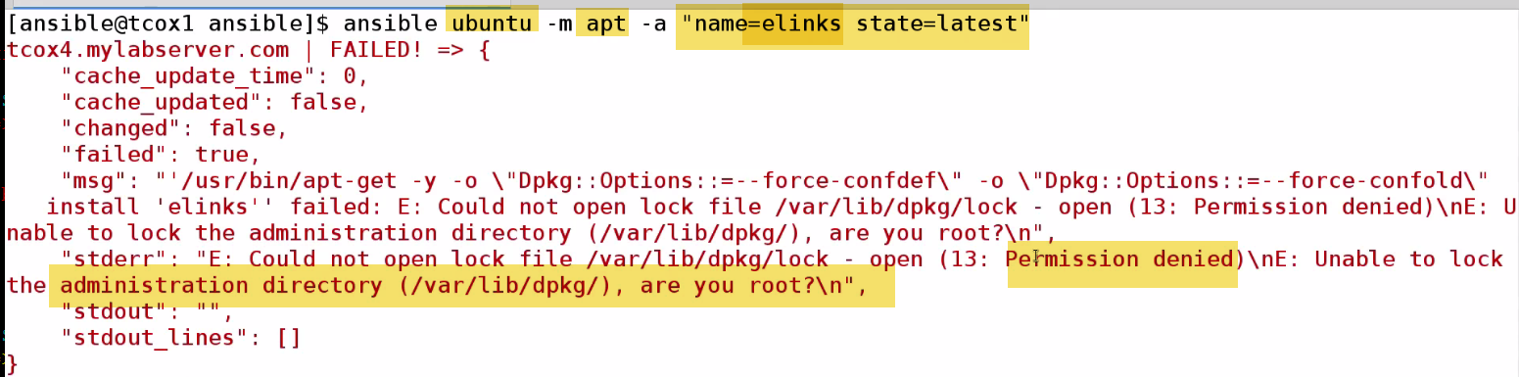

State=present🡪just install (Challenge: if we have old version of pkg, it will qualify as present, and wont get update..

**In most cases, we use latest…Use –s**

**Remove: State: Absent**



**Add User**

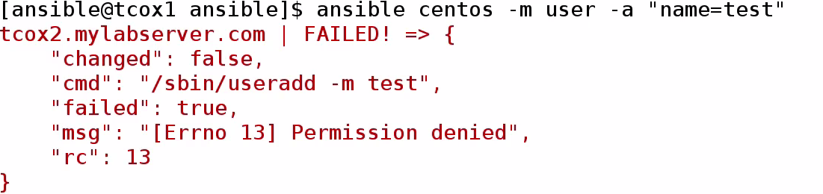

**Run a command**

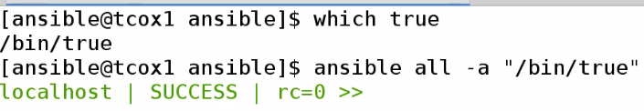

**-🡪Playbook Structure with YAML**

YAML: Key value list

Very Easy to read, which helps to define playbooks against nodes.

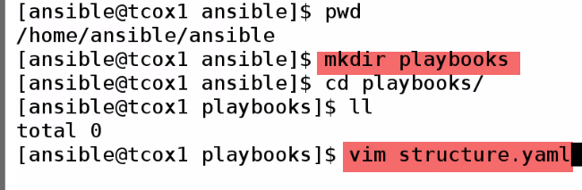

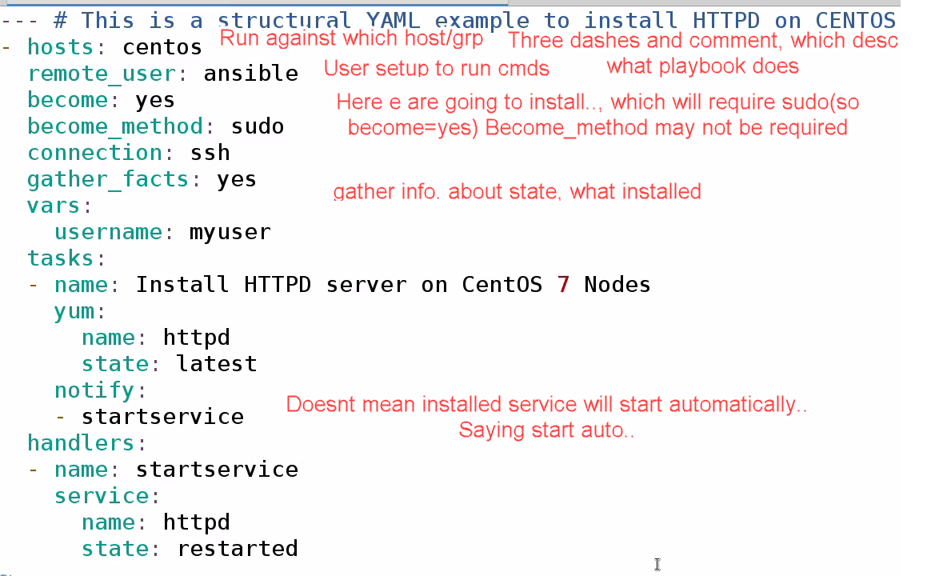

Everything is defined in sections..

Everyhing here belongs to hosts….Username belong to vars

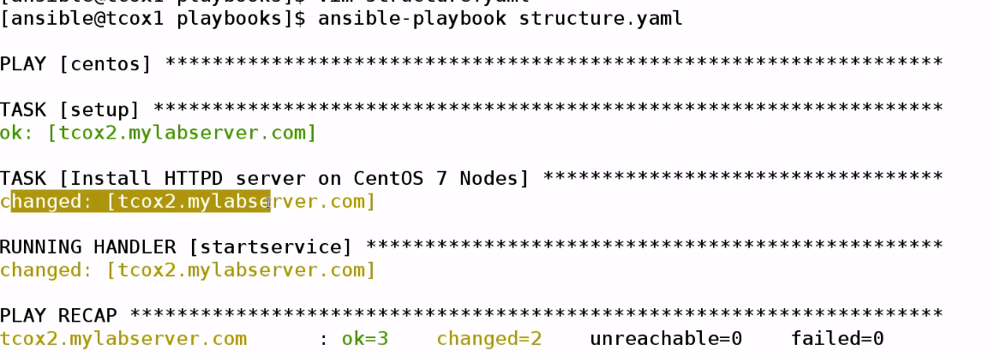

Playbook for Centos group is running..Task setup..Installing httpd—running startservice.

**2 Changes made : Install httpd, restart service**

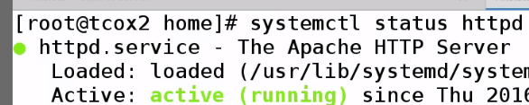

**-🡪 Gathering Facts**

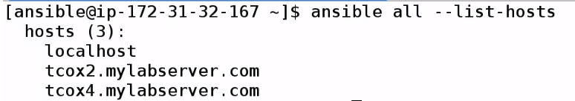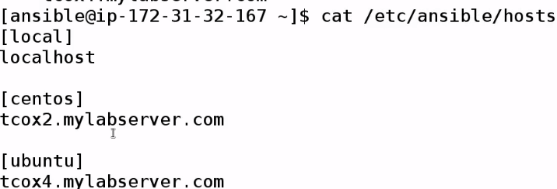

In playbook we mentioned, we can turn on or off gatheer facts

**_facts=(true) default**

Ansible needs to needs to determine someway, whether it can run plays asked to on remote nodes..

It goes and asks info. About that node..

We can explicitly get facts...if we want to..

****🡪It will gather facts by default when Ansible runs any playbook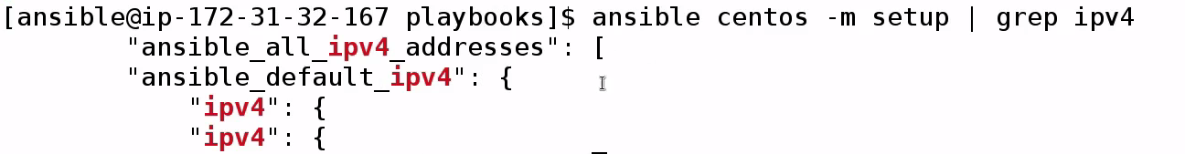

Actually lines in here..are in json -🡪 not good for grep---

FILTER SECTION THAT HAVE IPV4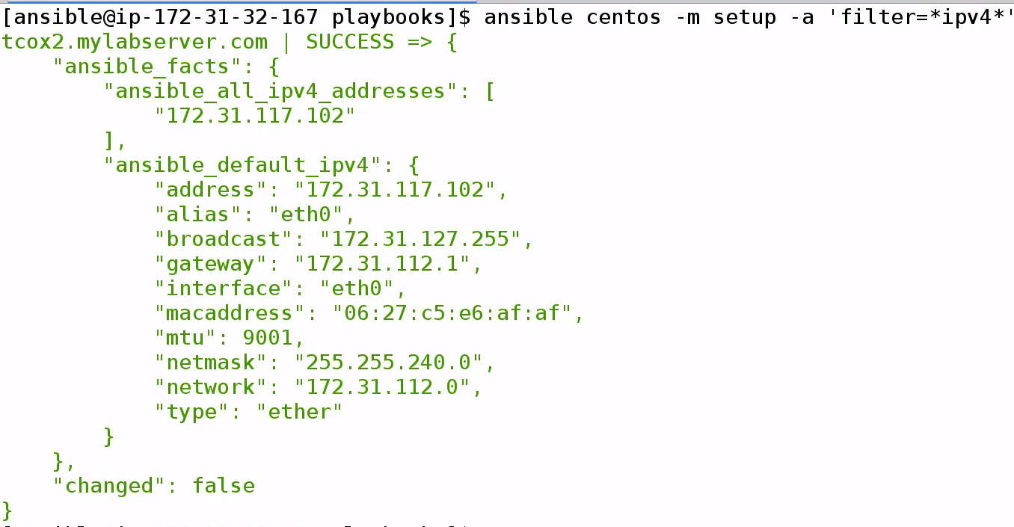

**🡪Create a localfile**

**Facts is output folder**

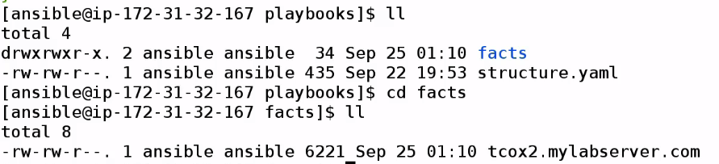

**Vim tcox2.mylabserver.com**



**Now, find key…We can use them in playbooks**

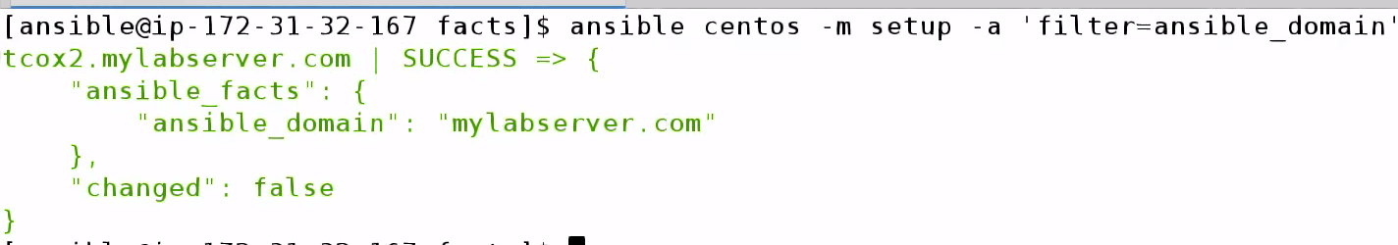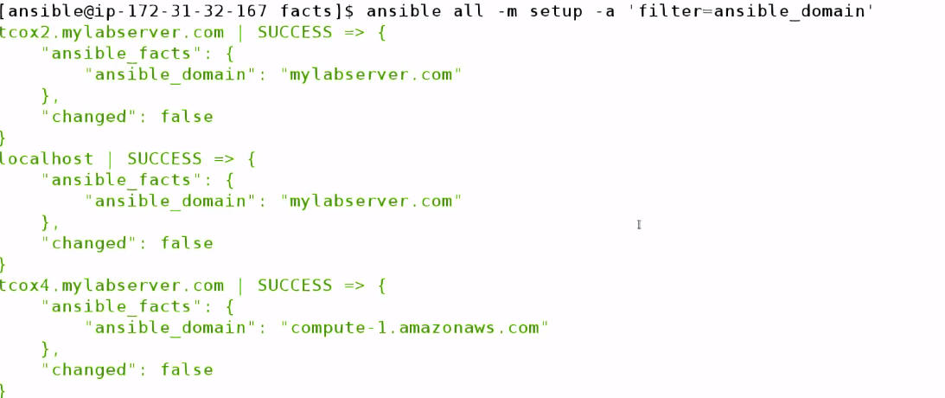

**-🡪 Variable Substitution**

**Variables can be used in playbooks in 2 ways:**

1. Variable section in playbook: So we can change once, instead of changing multiple times
2. Variable pass at run time

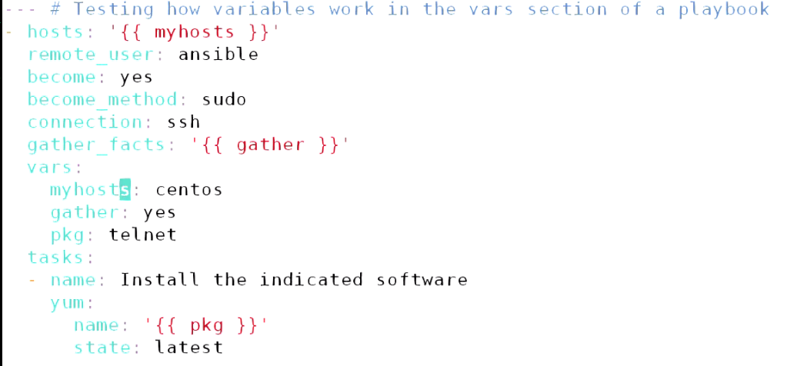

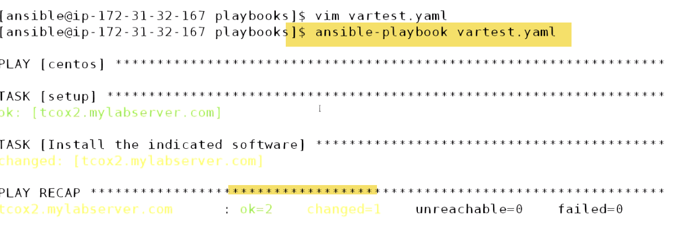



Command to centos group as sudo running yum module passing parameter telnet pkg to uninstall

1. Passing arguments

Remove variable section:

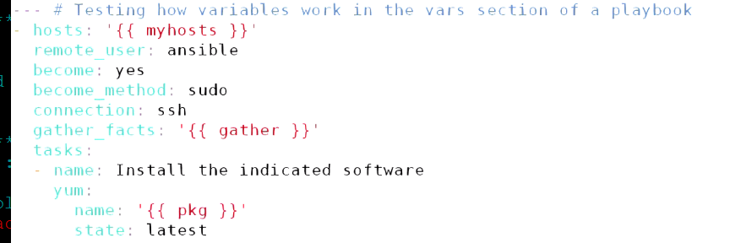



-🡪Debug Statement:

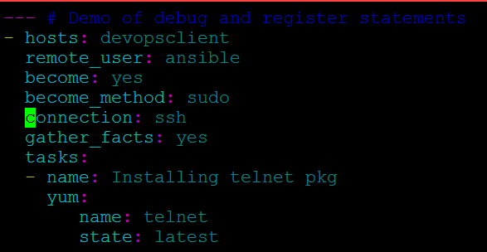

Let us say if we want to do on 100 servers or entire environment like upgrading.

I need to know:

-Which servers did not have pkg installed at all

- Which servers have software pkg updated

--If something expected happens??—I need to go to each client and check if telnet is installed

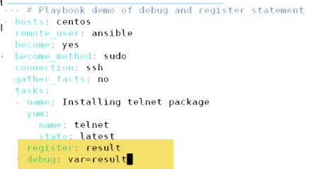

**-🡪Notifications and Handlers**

Ability to determine: When something run regardless of other event---Called as Notification and Handling.

While executing tasks within playbook and execute some control over(no need to use conditions) but it’s basicalaly saying if this thing run.. Run another thing. If 1st thing didn’t run..other will not run..

**Named as notification because: It fires off notification for section called as handler section to handle.**

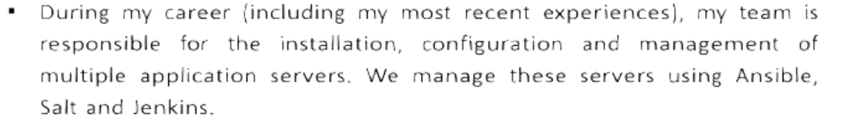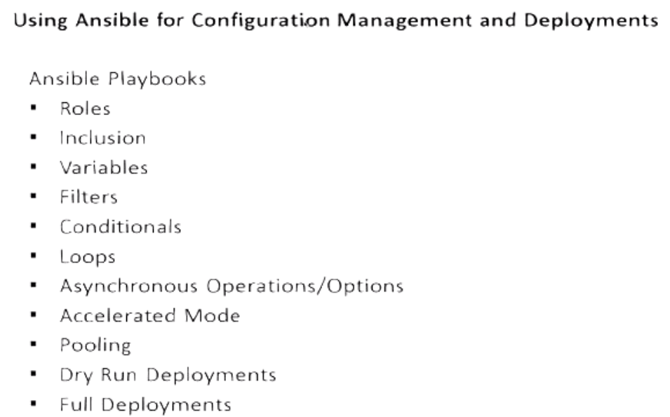

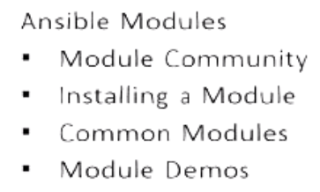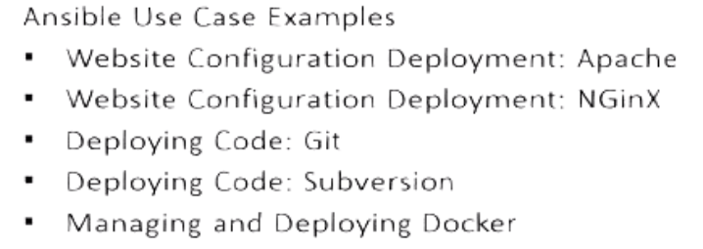

**Ansible Playbooks** are one or more scripts, which tell Ansible:

What to do

Where to do

How to do

What can be used to do it?

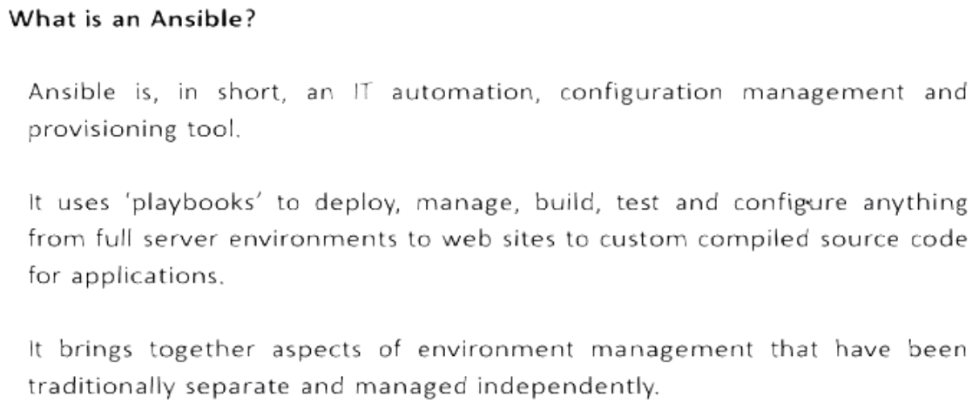

One stop shot for managing, deploying env..whether in Virtual, AWS, Azure or Openstack.

Configuring everything from OS deployment, Contsant deployment and delivery of Code Updates , builds

With Jenkins: In order to configure, Build, Test

With Docker: deploying and configuring Enterprise env. 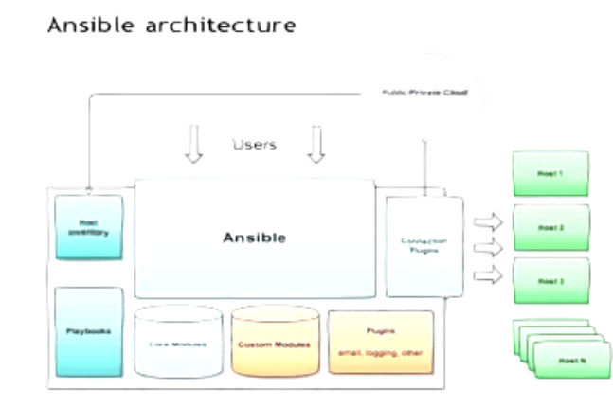

Every client can be a server.. Every server can be a client.. Config.

Server for 1 Config, Can be a client for other Config.

🡪With Ansible, we can make server deployment exactly same and consistent.

If we deploy webserver on centos7, every server is configured exactly same because same configuration is sent to each to these servers, when it spin up.

-- This ensures we haven’t introduced anything by manual configuration.. Which may cause hardly to troubleshoot.

--Additionally, may make up into system or environment issue. If system is mis-behaving there is no need to troubleshoot, we can reapply configuration. Pull node completely out.

Ex: in a webserver env.., have 10 nodes in cluster.One node is misbehaving, 9 are fine.

There is no need to troubleshoot that whay node is misbehaving , I can pullout—destroy, and redeploy fresh instance and put in my cluster.. My consistent config. Is going to heal my new node..

__--🡪 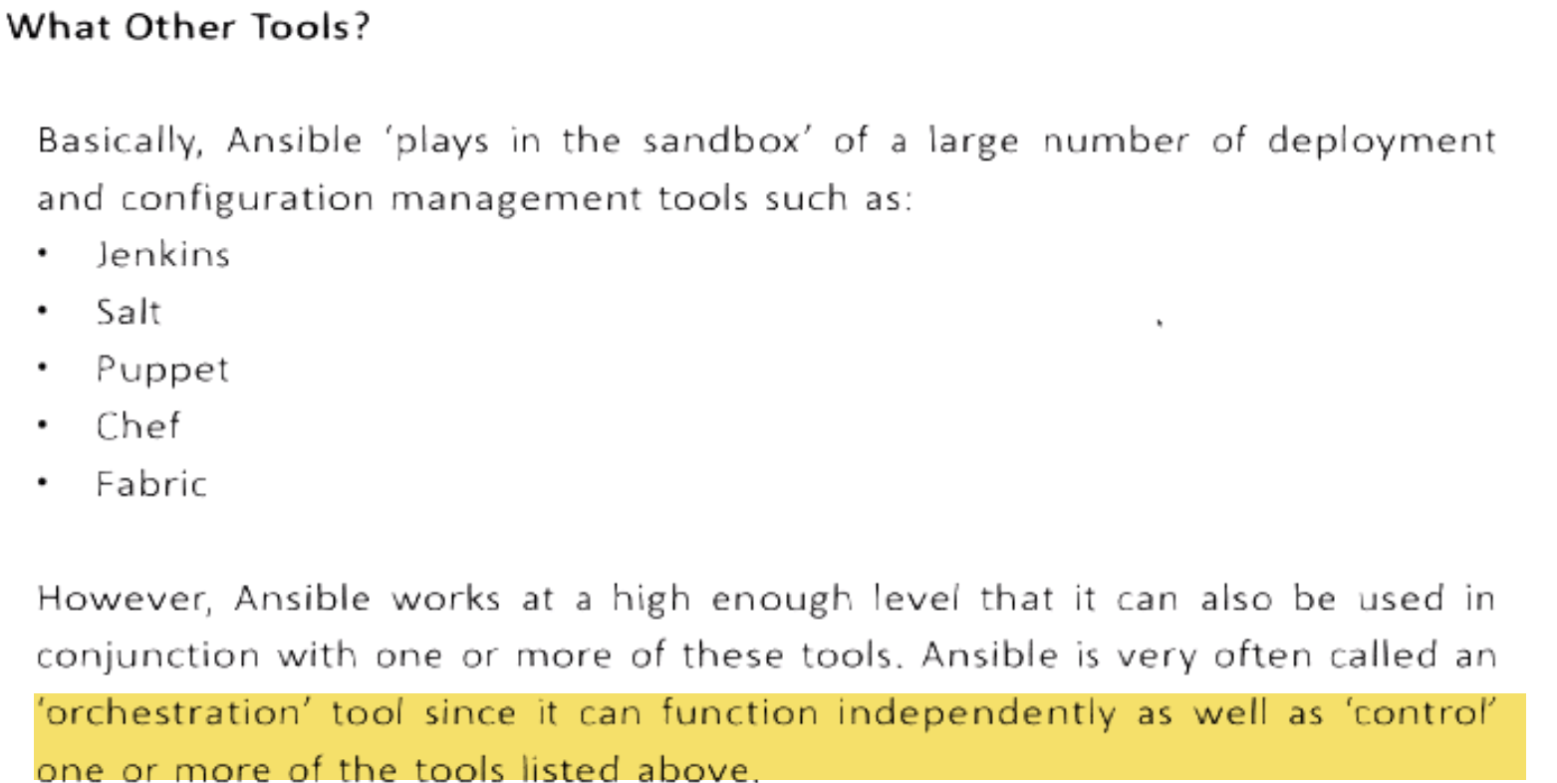

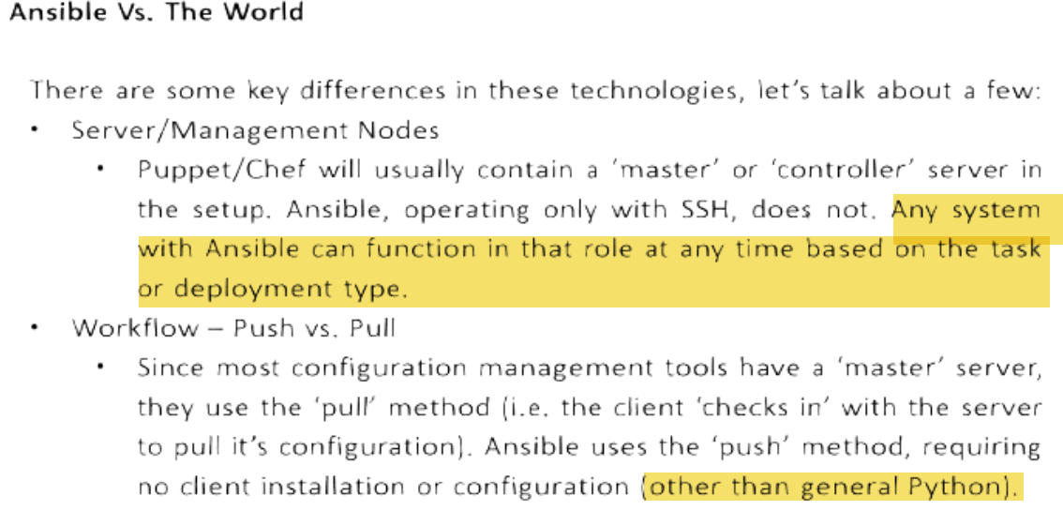 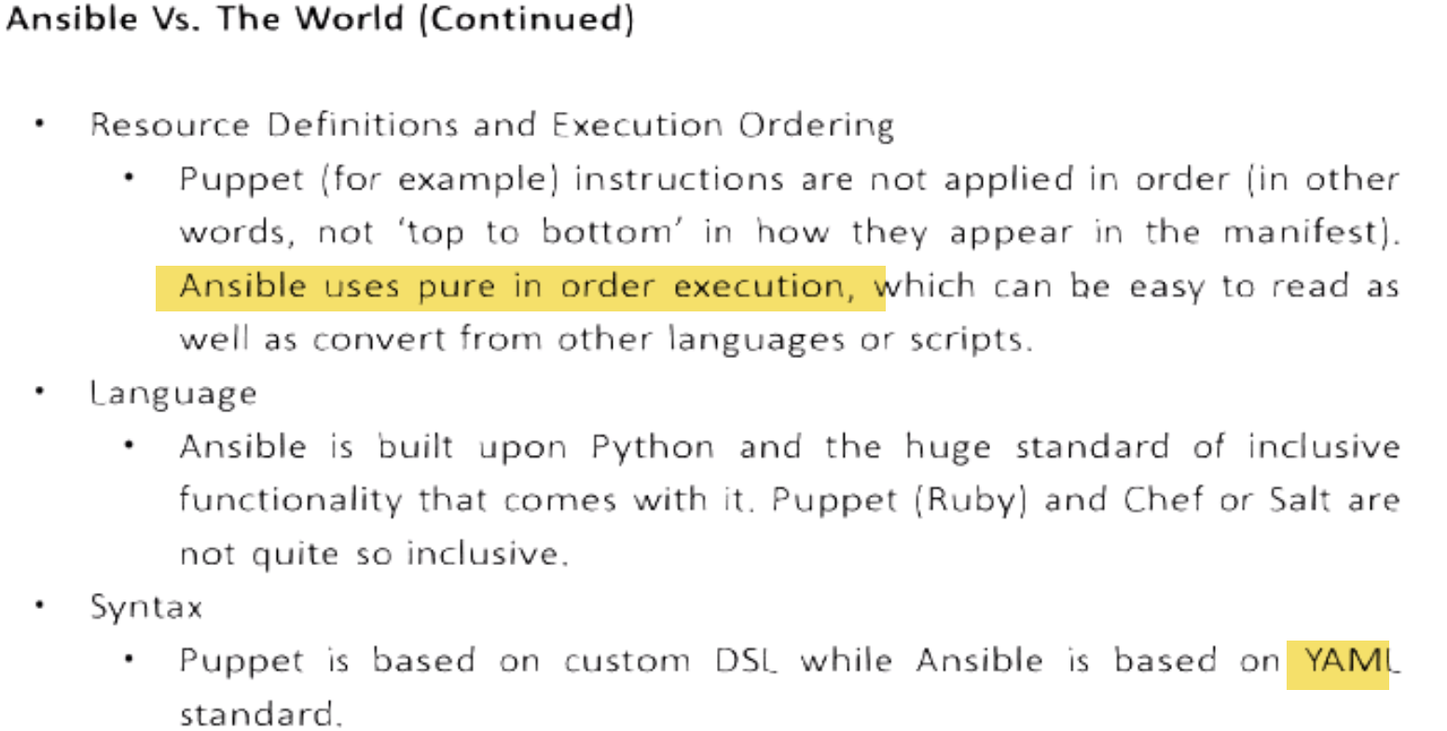





 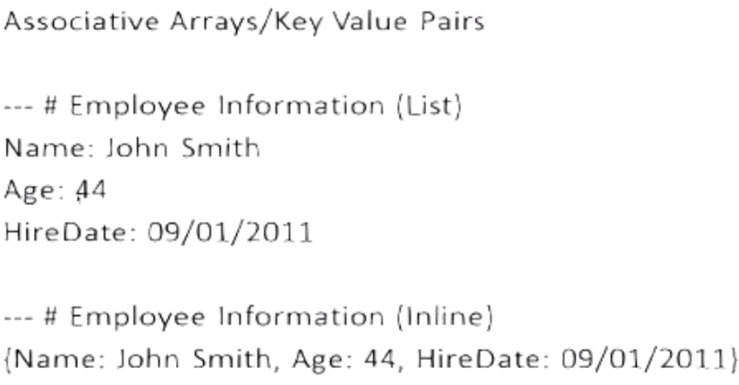



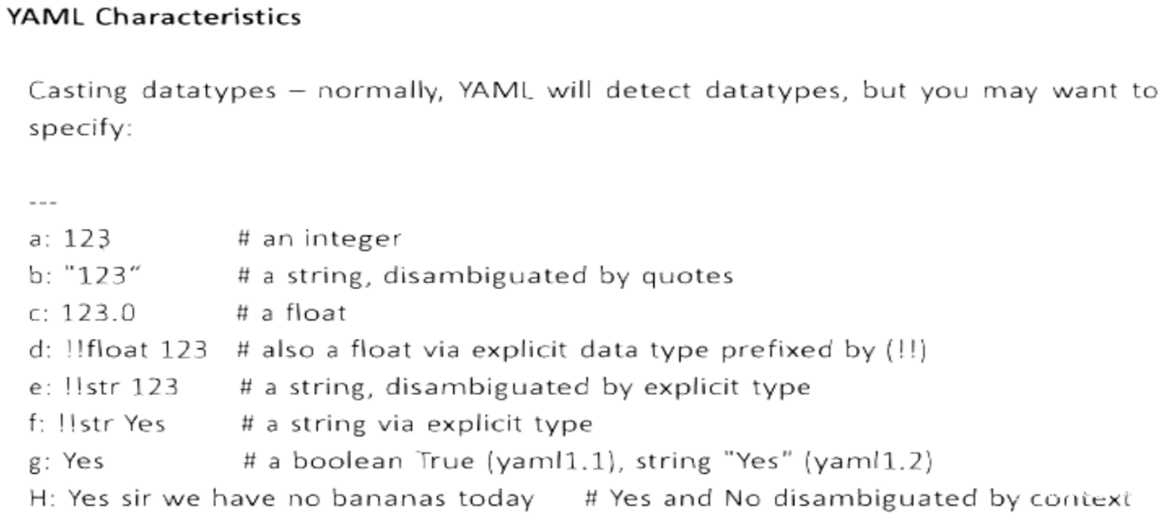

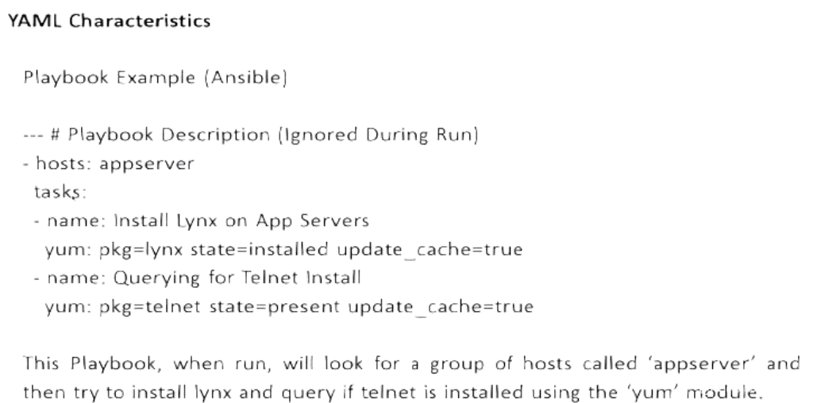

**HELP**

Man Ansible

Man Ansible-doc

Ansible-doc –list

Ansible-doc –list>list---will be helpful

Ansible-doc ec2

**Ansibe tower-🡪enterprise edition🡪reports**



**Use python 2.6 ..Not python 3(Can cause problems)**

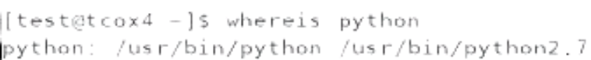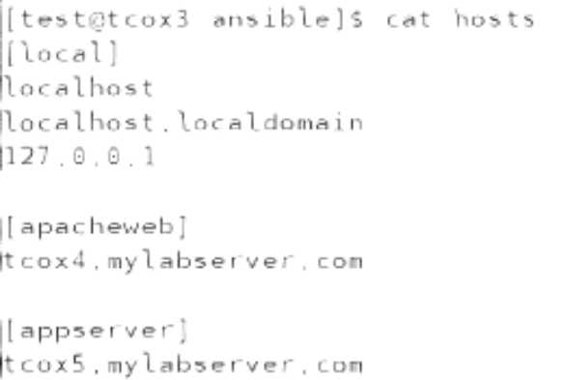 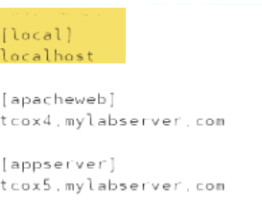

**Note:**

Ansible Config. Under /etc/ansible

Recommend: Setup shared n/w drive so that we can execute playbooks from any.

Ansible can be configured to run by root or user.

🡪 When we refer something locally, no eed to refer 3times in example..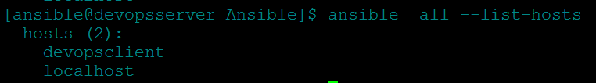

--🡪Override hosts file---Create hosts file at any place

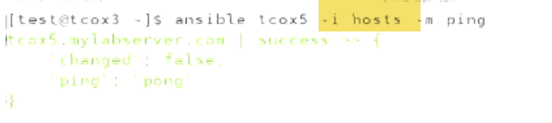

🡪How to overrirde /etc/ansible/ansible.cfg???

* IF I DON’T HAVE SUDO PRIVILEGES TO CHANGE ANSIBLE CONFIG FILE
* What if I want to define group of hosts that include in main hosts file

🡪1.) a.)Instead of 

We can copy ansible.cfg locally and

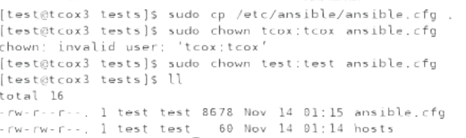

b.) Change inventory path to ./hosts (Current dir…hosts file)



c.) It will use current dir. hosts file

2.) If we change inventory path, need to set variable

So 1st look for ANSIBLE_CONFIG env.

Variable..2nd place current dir, wherever I ‘m running command

3rd: home dir of user running command

4th: /etc/ansible/ansible.cfg

🡪Roles

Ansible.cfg





No password will be asked, when running using sudo



--🡪

Check if nodes have telnet installed

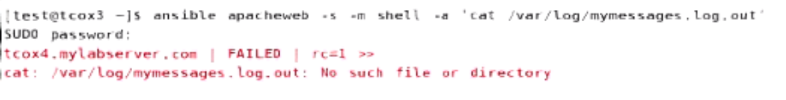

If command fails…RED

-🡪Check if ansible is able to run commands.

Ansible gather_facts using setup

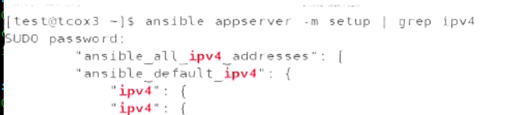

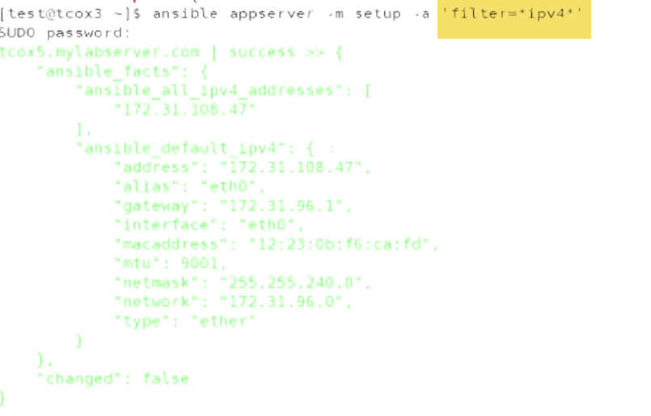

**\*ipv4\***

**-🡪**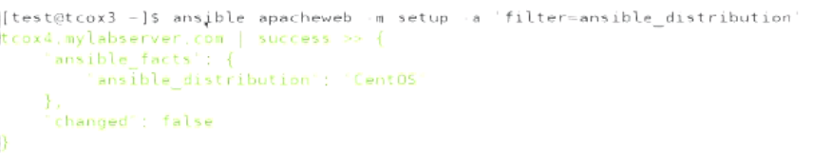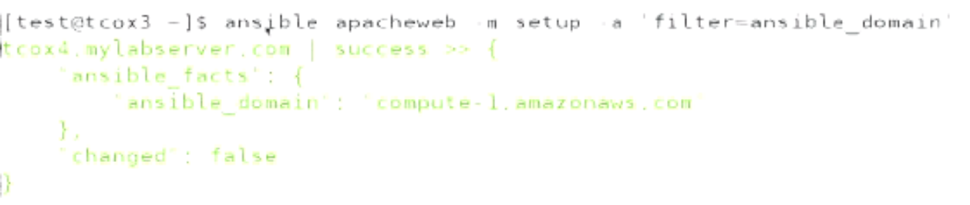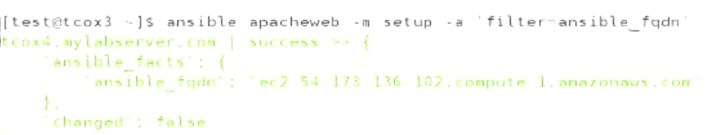



**-🡪**

**How to convert this into playbook???**

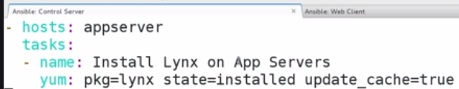

**🡪 If we want to run yum update.**

**We can do using cron job**

**-🡪Variable(Included as section vs included in file)**

Ansible execute from top to bottom.

Variables should me defined on top under vars section..Otherwise undefined

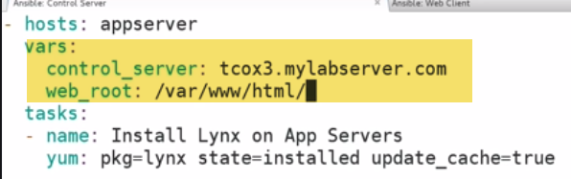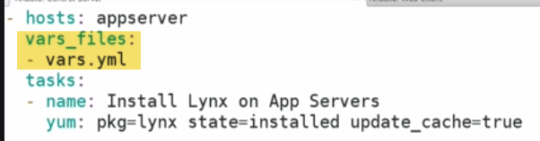

I can have variable defined in vars section as well..

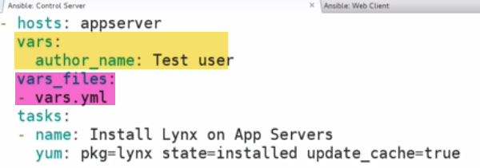

-🡪**Tells who(test user) to run, how to run(sudo) at target**

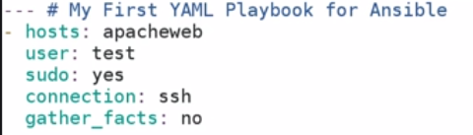

🡪Playbook-1:

1.)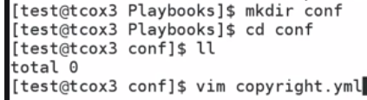 

2.) 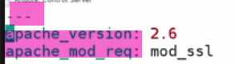

3.) 

It have 3 types of vars:

* var(within playbook)
* Var: outside(external file)
* Var: Populated at run-time prompted by ansible itself

Issue: 

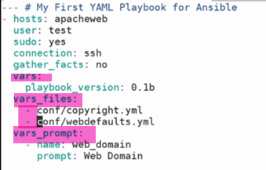

Anything that is external we have to use – before…Local not required.

-🡪

Number of modules:



Tasks: What we are going to do/actions in playbook.

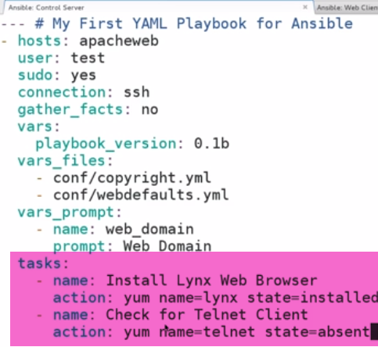

-🡪**Handlers:**

1.) Ability to notify when something happens

2.) Execute another set of tasks.

Although not a task, it’s a kind of own handler.

**Ex: install httpd and check if service is installed:**

Don’t configure handler if we want to run everytime in playbook..(Handlers run only 1st time) 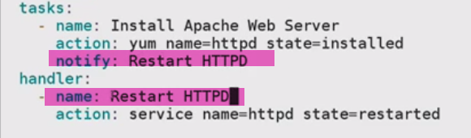

-🡪

We can specify hosts like an array:



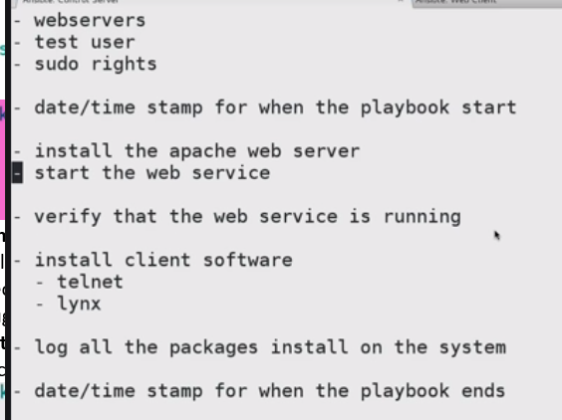--🡪Webserver.txt

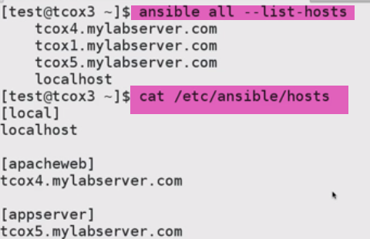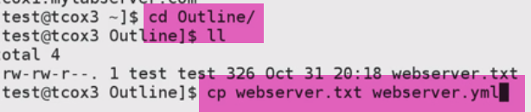-🡪rename to yaml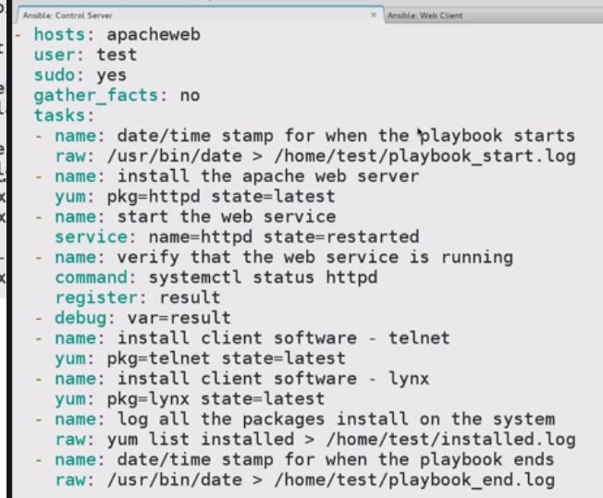

Check Syntax:



-🡪Running Playbook as a Dry RUN:

--check : connect to remote hosts. Look for what it will do on remote hosts using everyone of taks.., and what result might be..

Result: Wouldn’t be live..(Really wount be running commands)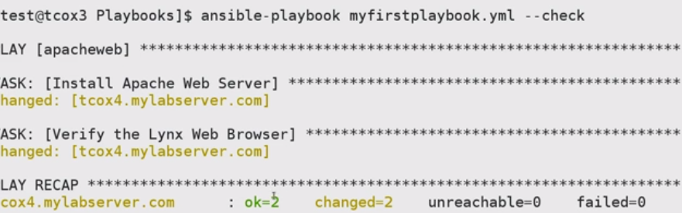

Change here=🡺 will be going to change if executed

OK=2, Change=2🡪 Install apache, lynx

Ok=2, Change=1🡪 IF apache installed, lynx to install

Ok=2, Change-1🡪 Lynx installed, Apache to install

Ok=2, Change=0🡪 both installed